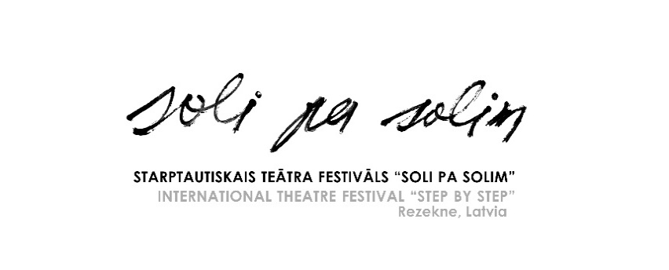

**13th International Theatre Festival**

**“Step by Step”**

**September 20–22, 2022, Rezekne, Latvia**

**Name of the festival:** The 13th International Theatre Festival “Step by Step”

**Website:** <http://www.rtt.lv>; FB: <https://www.facebook.com/rezeknesteatris/>

**E-mail:** [teartrezekne@gmail.com](mailto:teartrezekne@gmail.com)

**Address:** Rezekne Theatre, Bralu Skrindu iela 3, Rezekne, LV-4601, Latvia

**Event location:** Rezekne, Latvia

**Event date:** September 20 – September 22, 2024

**Deadline for Applications**: July 1, 2024

**Description:**

International Theatre Festival “Step by Step” takes place in Rezekne since 2000. The festival is organized by Municipality of Rezekne and Rezekne Theatre. The festival offers an opportunity to see various performances of different genres and forms. The discussions are organized after every show, where the theatre groups can meet the audience and hear out their opinion as well as find out the experts’ appraisal. These are lively, exciting, friendly and unforgettable days in Latgale – Eastern region of Latvia.

**Performance type:** Festival of all kinds of performance styles (small-form theatre shows, comedy, dance, physical, street theatre etc.), also in unusual places and original forms.

**Age group of actors:** Youth & adult theatre

**Performance duration:** Up to 60 minutes; if the show is presented in a small space, it might be performed twice during the festival.

**Attendees per group:** Maximum 8 persons

**Financial support:** The organizers will provide the participating groups with hostels, full board (three meals a day), and appropriate rehearsing time on stage with technical assistance, and free access to all the events during the festival.

Accommodation (3 nights) and meals are covered for maximum 8 participants of the group.

The travel and transportation costs must be covered by the participants themselves. Theatres are responsible for having a license to perform the show.

**How to register:** **Filling out the application here:** [**https://forms.gle/p2THk1CMUM9gKDSRA**](https://forms.gle/p2THk1CMUM9gKDSRA)

Or

The groups should send by e-mail [teartrezekne@gmail.com](mailto:teartrezekne@gmail.com)

* Application form <https://failiem.lv/u/pyrd5vf9wr>
* Description of the performance (max 1 page)
* Short description of the group
* List of participants (indicating name, gender, age, function in the group)
* Technical description of the performance (indicating – equipment, lightening necessary)
* 5 photos of the performance (for festival promotional materials)
* Full video record of the performance (link to material)

We inform you that personal data will be processed only for the festival and data will not be stored after the event.

The analysis of the submitted shows and the approval of the participants will take place by 1 August 2024.