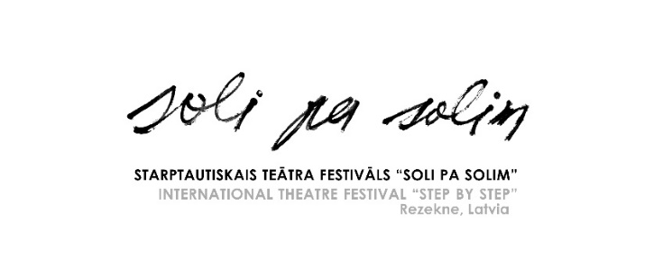

**13th INTERNATIONAL THEATRE FESTIVAL “STEP BY STEP”**

**SEPTEMBER 20–22, 2024, REZEKNE, LATVIA**

**Application form**

|  |  |
| --- | --- |
| **Name of the company** |  |
| **Director of the company/ Contact person** |  |
| **Address** |  |
| **phone** |  |
| **E-mail** |  |
| **Title of performance** |  |
| **the autHor** |  |
| **Director of performance** |  |
| **Genre of performance** | ** Drama  Comedy  Tragicomedy  Tragedy  Musical  Poetry  Monodrama  Performance  Street theatre**  ** Pantomime  Claunade  Modern dance show**  ** Thriller  Other _________________** |
| **Length of performance**  **(max 60 min.)** |  |
| **Setting up time** |  |
| **Removal time** |  |
| **TOTAL NUMBER OF PARTICIPANTS (INCLUDING DIRECTOR)** |  |

Please attach the following:

* Description of the performance (max 1 page)
* Short description of the group
* List of participants (indicating name, gender, age, function in the group)
* Technical description of the performance (indicating – equipment, lightening necessary)
* 5 photos of the performance (for festival promotional materials)
* Video record of the performance (link to the material)

We inform you that personal data will be processed only for the festival and data will not be stored after the event.

Application form sent to: [teartrezekne@gmail.com](mailto:teartrezekne@gmail.com)

Deadline for Applications: July 1, 2024

Mara Zalaiskalns, Rezekne Theatre, Bralu Skrindu iela 3, Rezekne, LV-4601; LATVIA

Festival and Rezekne Theatre page: [http://www.rtt.lv](http://www.rtt.lv/)

FB: <https://www.facebook.com/rezeknesteatris/>