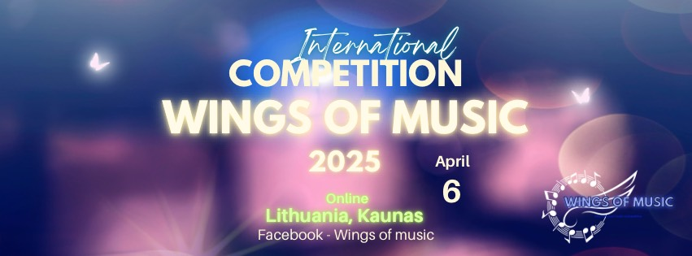

IV INTERNATIONAL COMPETITION FOR INSTRUMENTALISTS - VOCALISTS

"Wings of music 2025"

**REFERENCES**

GENERAL

The Regulations of the IV INTERNATIONAL INSTRUMENTALIST - VOCALIST COMPETITION "Wings of music 2025" regulate the requirements for the participants, the organisation of the competition and the procedure of the awards.

1. The competition is organised ONLINE.

2. The aim of this competition is to reveal the creativity, artistic individuality and mastery of performance, creativity, aesthetic taste, to establish creative contacts, to promote creative cooperation between students of Lithuanian and foreign music schools and their teachers, and to promote the dissemination of professional experience.

II. PARTICIPANTS

**Performers are divided into groups:**

* **Folk/national string instruments.**
* **Woodwind and brass instruments.**
* **Piano, Organ, Accordeon**
* **Strings (guitar, violin, harp, cello)**
* **Vocals (classical, jazz, pop, folk)**
* **Best video**

3. By submitting the entry form, you confirm that you have read and agree to the terms and conditions of the competition terms and conditions.

4. The competition is open to: soloists, duets, trios, ensembles, orchestra, choir and mix group.

5. The contestants are divided into six age groups, which are taken into account in the evaluation of the contestants' performances.

* A - up to 6m
* B - 7 - 9 years;
* C -10-12 years;
* D - 13-15 years;
* E - 16-19 years;
* F- 20+

III. TIMING OF THE COMPETITION

6. The results of the Online contest will be announced on 6-9 April 2025.

IV. REGISTRATION OF PARTICIPANTS

7. Participants must complete the following online registration form at the time of registration:

For vocalists:

https://forms.gle/PabPgwsYqsDiDbAb6

For instrumentalists:

https://forms.gle/Bvz12LPziDoH6Eay7

8. Applications will be accepted **until 23 March included.**

V. ENTRY FEE

9. Participation fee:

10.1. Soloist (1 person) - EUR 25 (with award) , EUR 15 (diploma only)

10.2. Duet (1 person) - 18 eur (with award), 10 eur (diploma only)

10.3. Trio (1 person) - 14 eur (with award), 8 eur (diploma only)

10.4. Ensemble mini 4 -12 (1 person) - 12 eur./person (with award), 7 eur (diploma only)

10.5 Choir or Orchestra from 13 persons - 10 eur /person (with award), 50 eur for all group (diploma only)

11. The fee is non-refundable.

12. The entry fee must be paid at the time of registration and the bank payment document must be attached when filling in the online registration form.

If a performer participates in more than one category, the fee is payable for each category.

13. Requisites for payment:

Marija Teresė Jakelytė

Account: LT34 3250 0334 9052 3940

BIC / Swift - REVOLT21

Revolut Bank UAB

Constitution Ave. 21B, 08130, Vilnius, Lithuania

Payment must include - Wings of music, participants first name and last name

VI. COMPETITION REPERTOIRE

14. Each participant (soloist, duo, trio, ensemble) performs 1 (one) piece of their choice

work. The duration of the work is up to 4:00 minutes. Category F - up to 10 minutes

15. The competition is open to all genres of instrumental and vocal music. Participants may perform songs/works by Lithuanian and foreign authors and their own creations.

16. The Contestant must perform his/her performance only live with a minus phonogram. Soloists' backing vocals may be recorded in fragments without duplicating the main part. The main part may not be duplicated by any musical instrument. Instrumentalists must be visible in the footage at their full height.

VII. EVALUATION OF PARTICIPANTS

17. The jury of the Competition is composed of an international panel of competent professional musicians.

18. All age groups will be awarded 1st- 3rd places. The jury judges by closed ballot.

19. GRAND PRIX Prizes are awarded according to the highest scores awarded by the jury.

VIII. EVALUATION CRITERIA

20. Musicality, instrument control technique.

21. Arrangement, interpretation, originality, artistry.

22. Intonation and voice technique.

23. Aesthetics of the performer(s), stage image.

IX. AWARDS

24. All participants will be awarded 1-3 place diplomas.

25. 1st- 3rd place winners are awarded diplomas and medals. (The cost of postage is included in the entry fee)

26. GRAND PRIX winners are awarded diplomas and special prizes for this nomination.

27. Teachers who prepared the participants receive letters of appreciation

28. In the absence of worthy applicants, the GRAND PRIX Prize and other prizes may not be awarded. In the event of a tie between several Contestants, the Chairman of the Jury shall have an additional vote. The decision of the Jury is final and not subject to dispute.

IV. CONDITIONS OF THE COMPETITION AND SUBMISSION OF THE VIDEO

29. The competition will run remotely until 23 of March 2024.

30. Entrants must submit a video of their performance, filmed from start to finish, without editing or pauses.

31. The video must be taken with a steady, stationary, horizontal camera. The recording must show the performer in full height.

32. Preferably in concert attire.

33. The video is uploaded to the contestant's personal YouTube platform or to the YouTube platform of the educational institution where they are studying.

34. The entry to the video must remain until the results of the competition are announced.

35. The title of the video must include the author of the work being performed (in the original language) and the exact title of the work.

36. The description of the video must include the name of the performer, as well as the name of the concertmaster (if the work is performed with the accompaniment of the concertmaster or a phonogram/recording prepared by the concertmaster).

37. The link of the saved entry, as well as the artist's photograph, shall be uploaded in the specified section of the entry form.

38. If you have any questions, please contact: [Konkursas.muzikos.sparnais@gmail.com](mailto:Konkursas.muzikos.sparnais@gmail.com)

**The results of the competition and other information related to the competition will be published on the competition's Facebook page** [**https://www.facebook.com/profile.php?id=61557817070337**](https://www.facebook.com/profile.php?id=61557817070337)

**By completing the application form, you agree to the publication of your photograph and video on the Facebook page of the competition.**

